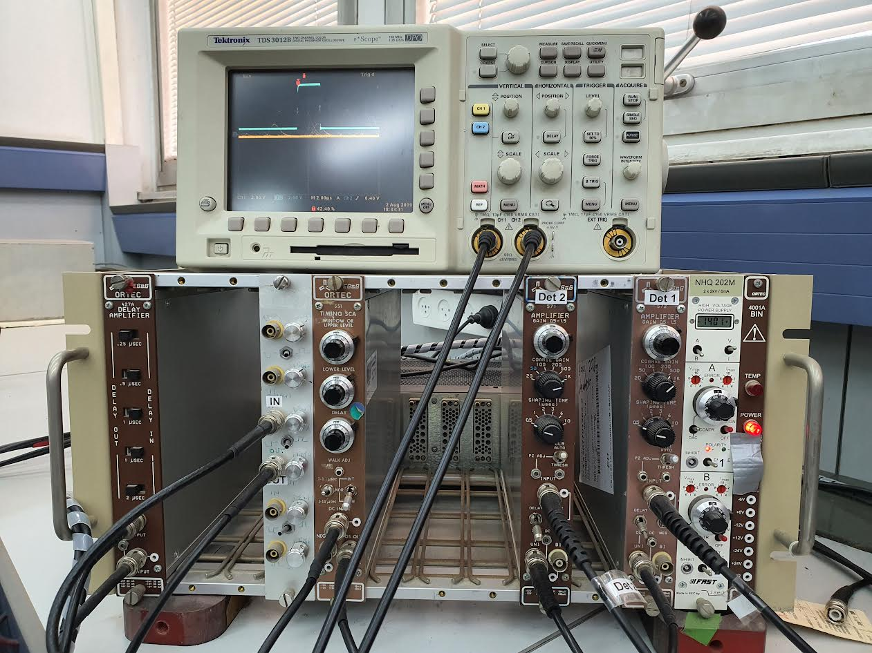

In this part, we use both **Detector 1** and **Detector 2**:  
 **Detector 1** is connected to **NaI(Tl)** (receiving gamma ray deposition),  
 and **Detector 2** is connected to the **plastic scintillator** (registering electron deposition via voltage).

**What process takes longer?**

**Detector 1** is connected from **"UNI"** using an ordinary black cable to the **"DELAY AMPLIFIER"** (**DC ADJ INPUT**),  
 and from the **"DELAY AMPLIFIER"** (**OUTPUT**) to the next stage.

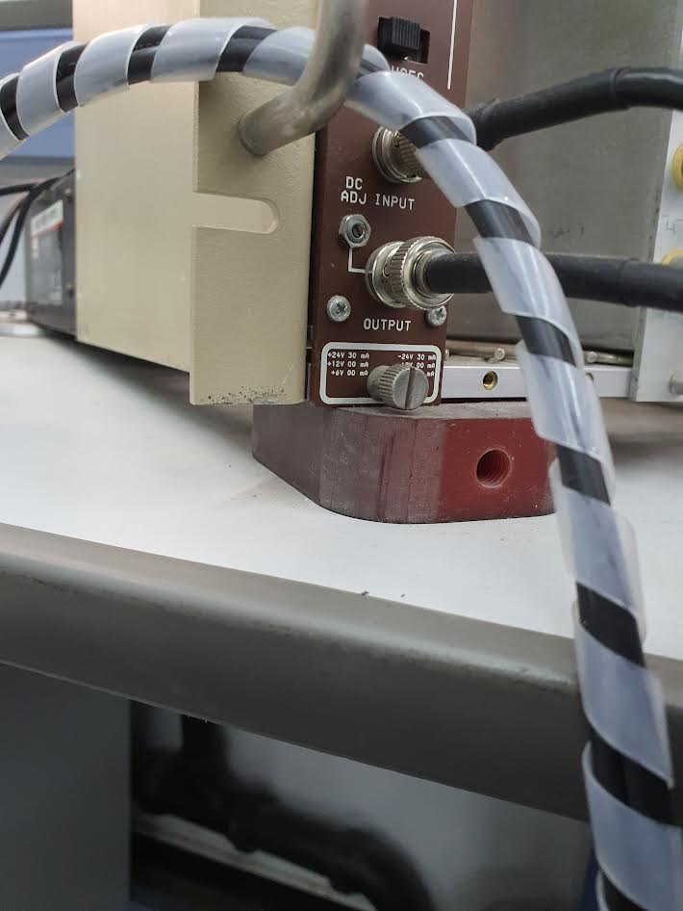  
From there, we reach a junction: which is connected to * *MCA SIGNAL \** and to the Oscilloscope(CH1)

Now we use * Det 2 * cable which enters the “ Det 2 ” (INPUT) => in “ Det 2 ” there is an output cable which is connected to (UNI) :   
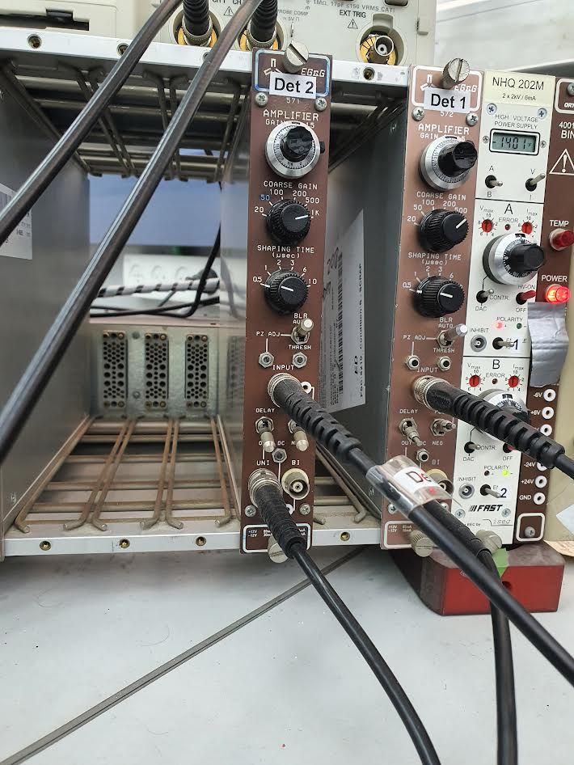  
This cable from “Det 2” goes to “TIMING SCA” (DC INPUT) => and the output cable from “TIMING SCA” is (POS OUT)  
 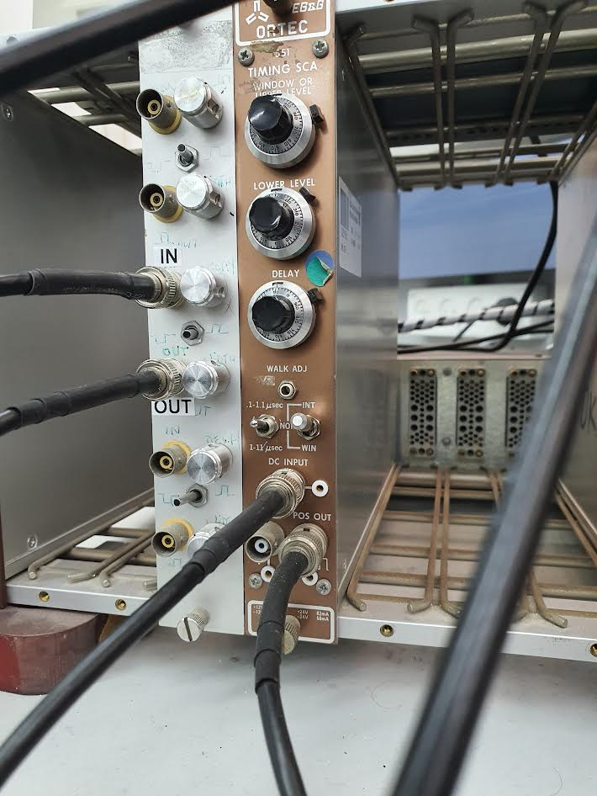  
  
So from the “TIMING SCA” (POS OUT), with the regular angle, we enter the “Silver-pulse unit or delay wind and delay unit” (IN) => the output is (OUT):  
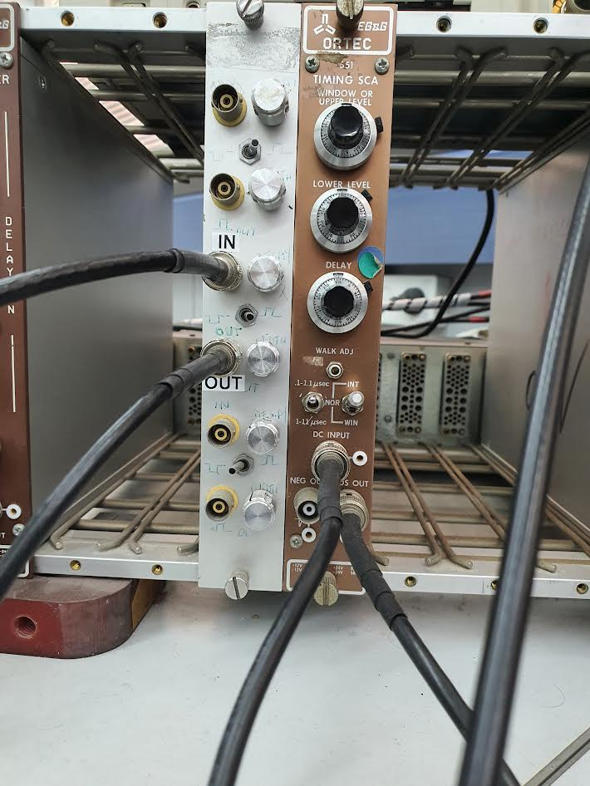  
Now from the “Silver” (UOT) we go with the cable to a junction which is connected to * MCA GATE * and to the “Oscilloscope” (CH2):  
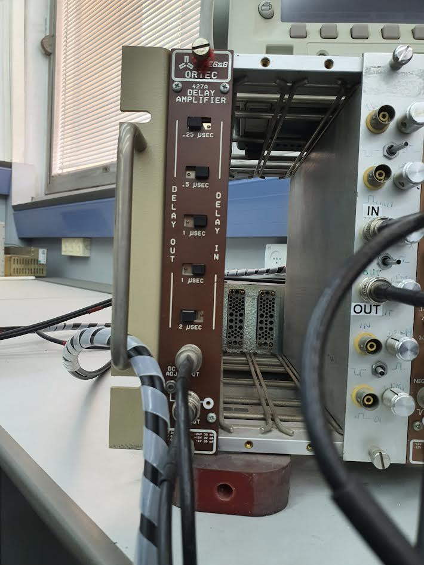

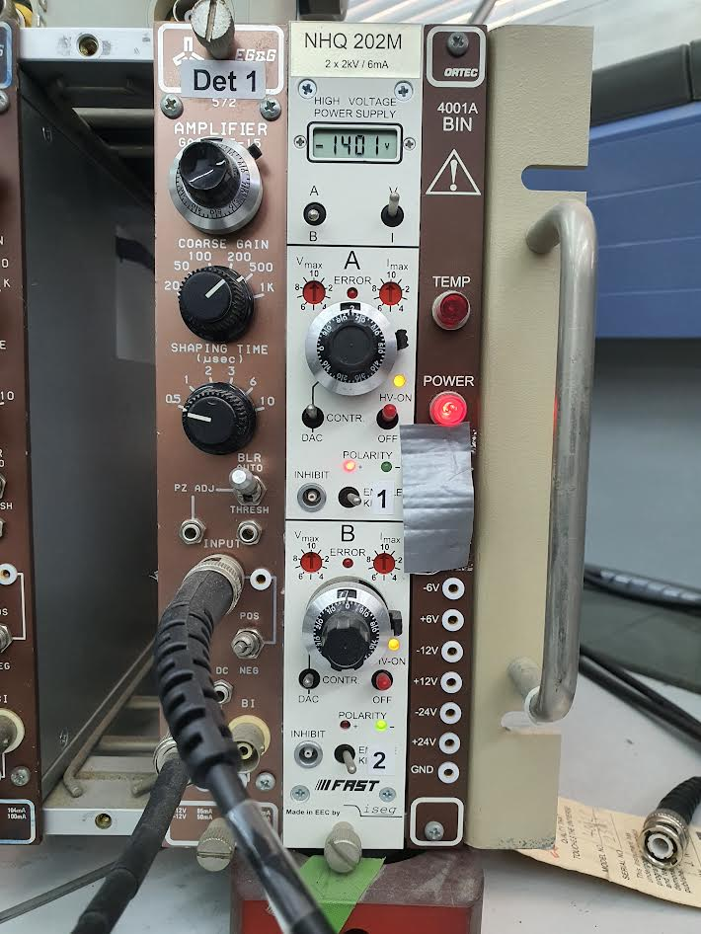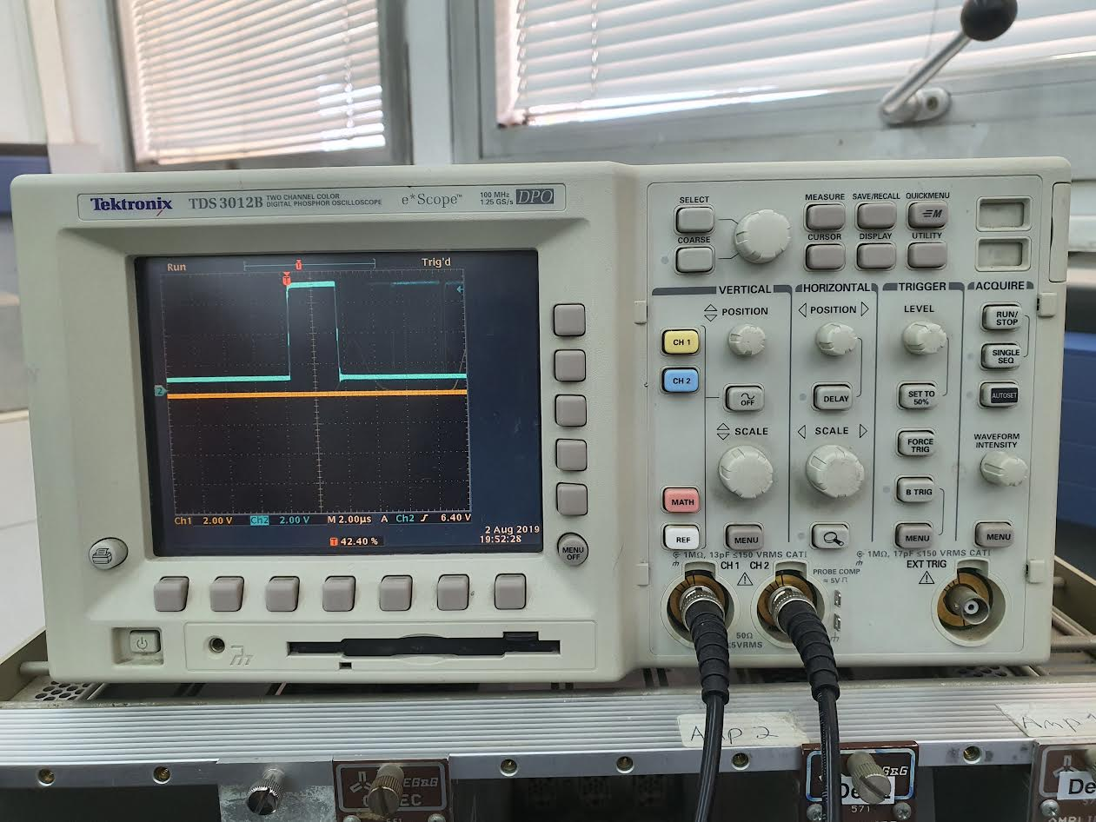  
  
  
  
  
System in part B(Coincidence Compton Scattering):  
Detector 1 = NaI(Tl) => detects gamma rays (the scattered photon), produces analog signals.

Detector 2 = Plastic scintillator => detects recoil electrons (the electron that the photon kicked during Compton scattering) produces analog signal => sent to Timing SCA => produces logic pulse.

Goal = only measure an event when both detectors see something at the same time => a real compton event (gamma + electron).  
  
**Why is the Timing SCA connected to Detector 2:**  
Detector 2 (plastic scintillator) gets a fast signal when the electron passes through.  
The Timing SCA takes this fast analog pulse and creates a fast logic pulse ("YES, an electron arrived!") if the signal is strong enough.  
Timing SCA watches Detector 2 and says: "If a real electron comes, i send a clean signal to open the gate!

Signal path:   
Plastic Scintillator (Det2) signal is processed through: Amplifier & Timing SCA =>fast logic pulse is made.  
NaI(Tl) signal (Det1) is delayed using the Delay Amplifier. so that it aligns with the electron signal timing.

Shortly :   
Det2(electrons)=>Timing ACS(int & wind)=>delay & Pulse Width Unit (blue)=> Oscilloscope(Ch 2) and MCA GATE

Det1(gamma)=>Delay amplifier (yellow)=>MCA SIGNAL & Oscilloscope(Ch 2)

Detector response time : (minor and not included)  
Plastic scintillator(Det 2) => fast response => The electron immediately produces light and a fast PMT signal.  
Na(Tl) detector (Det 1) => slow response => Gamma signal arrives slightly later due to scintillator properties.

We are trying to find the gate for the upper and lower limits (for the electron signal) => For small angles, we start with relatively low limits (like lower limit around 0.5)=> because at small angles the recoil electrons have low energy. On the other hand, for large angles (130 etc) => the starting point of the window is at l=7 => which corresponds to the fact that the electron energy is much higher=>These limits are connected to the voltage pulse height as Roi explained to us, using *l* and *u*)=> so we know that the pulse height (from electrons) will be smaller for theta=0 and larger for theta=130.

When we change the “delay amplifier”(which is connected to the gamma signal = the yellow line) “so the yellow is gammas”: we see several pulse heights when lower level is set to l=0 since this captures all gamma signals that might be candidates for coincidence. We don’t see on the screen gamma events that have no coincidence at all => Changing the delay amplifier shifts the yellow (gamma) pulse left or right on the screen.

If, for example, we want to include all electron energies using the SCA, we set l=0 =>As a result, we get a lot of yellow pulses that come from all the gamma energies we have (we see several different heights of the yellow pulses)...So when we try to find the "low electron limit," we will get the

How do we know which “limit l” to choose? We start with “l=0” ( so that all the gamma pulses are allowed through), and then we check if there is a specific pulse that repeats itself consistently.

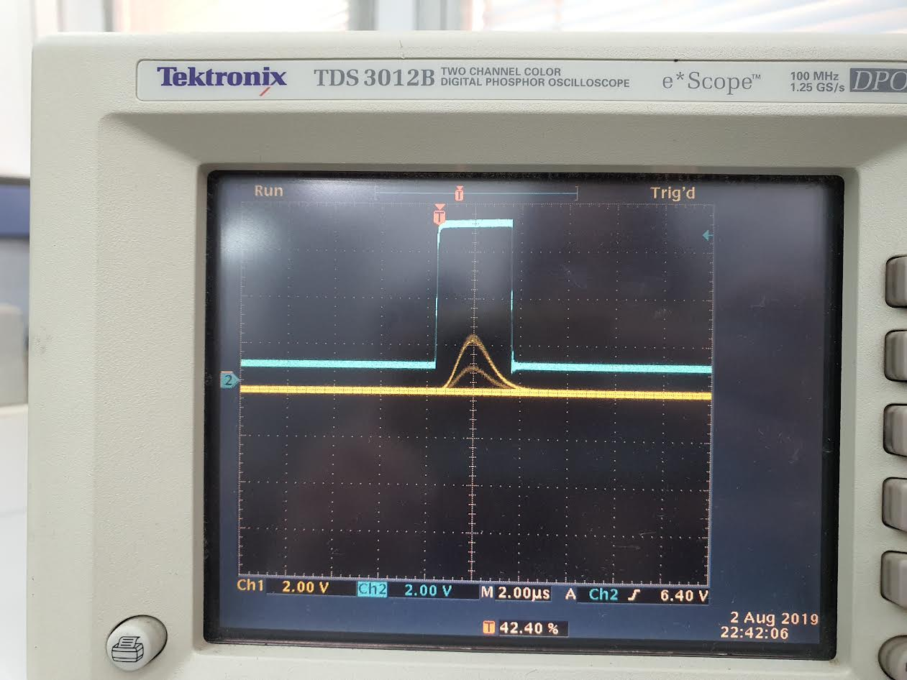

We start the measurement (with “l=0”) and simply watch the screen

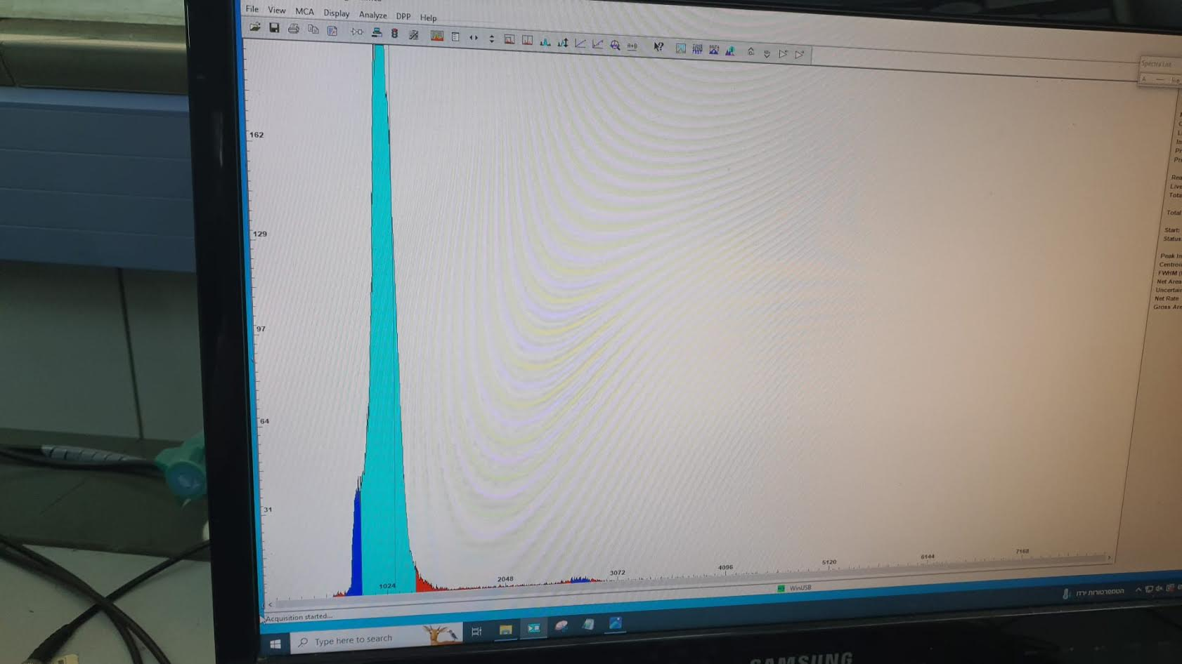

We see a sharp peak(in this case, at low energy) => and since this is a super high-quality system that measures really well, we can be confident it's real (Even though we're accepting all energies (with l=0) the one that's actually correlated with the Compton scattering will give the highest peak) .   
If under the “net area,” we’ll also see a very high rate everywhere else — including unrelated signals. So we need to start increasing the “low” limit from there

Thumb rule :   
Small angles => low electron energies(CSA l=low, blue) & high photons (high amplitude of yellow)

The steps : we start from int =>then open the “traffic light”(set to meas)=> we see a super fast peak rate and net area grows rapidly. for example, the rate can reach 1000 counts per second.

We start to raise the “lower level” until we reach a point where we see the rate **increase** by about 10–20 counts.

After that, we lower it by about 0.5 to 1 unit => Eventually, we get around 20–100 counts under the net area per second.

Now we go to we “window” => and we try to close(isolate) the best signal => On the oscilloscope, we’ll see a repeating yellow peak inside the blue square =>and as we adjust the upper and lower limits=> the rate may become lower compared to the first case => Eventually, on the Amptek DppMCA computer screen, we see that most of the counts occur at the desired photon energy.  
Sometimes, we also see outliers.

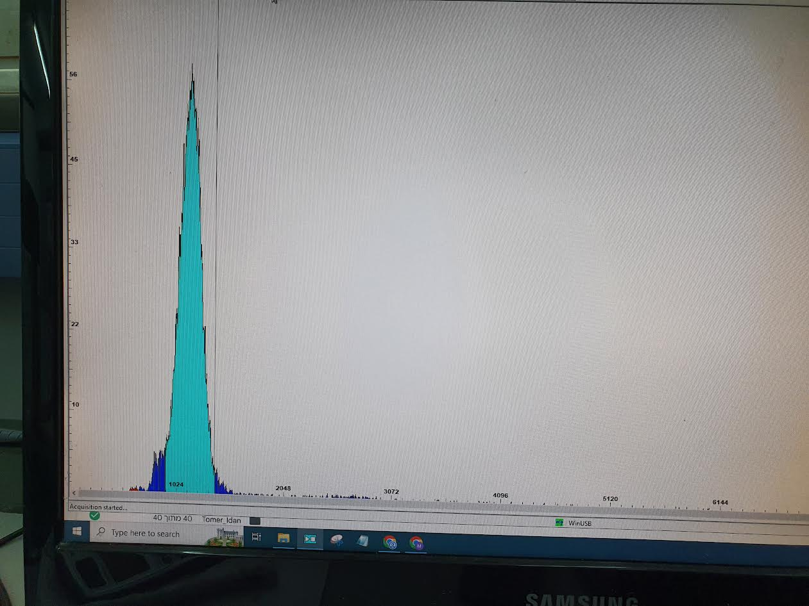

For example, we see a small “bump” on the right side. This happens because we chose too large a window, which allowed some yellow signals with high energy (⇔ high amplitude) to fall inside the square area and be counted. If we don’t calibrate the energy range properly, we may also get a wider FWHM, which reduces energy resolution.

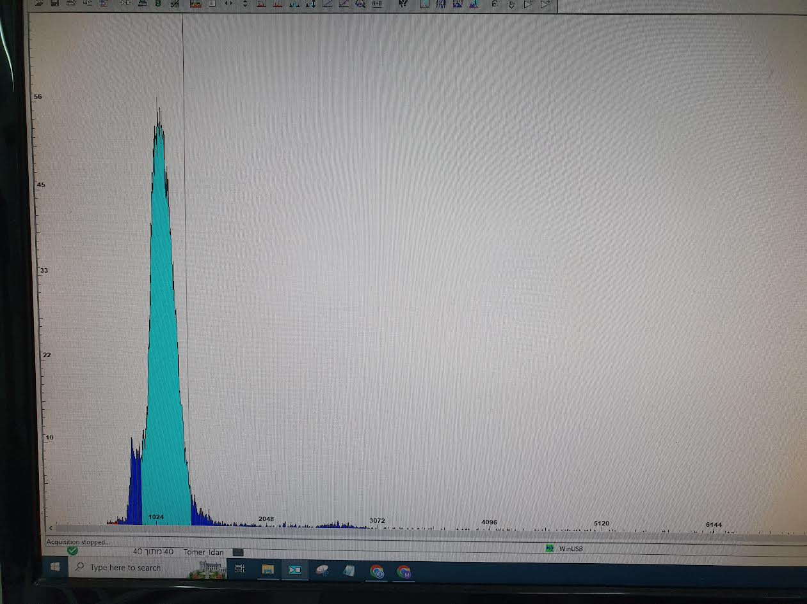

The system does not check whether the energy of the gamma or the electron is “correct” or “Compton-like.”

It only checks: Did both detectors fire together (within a few hundred nanoseconds)?

As we go to higher angles => the rate with “l=0” becomes much slower.

We also observe that at higher angles, the Live Time becomes much shorter compared to the Real Time.

At small angles (theta= 20), the counting rate is higher => quick data collection.

At large angles (theta=140), the counting rate becomes lower => longer measurement time needed.